Danielle Peterman
HL 440 Critical Issues
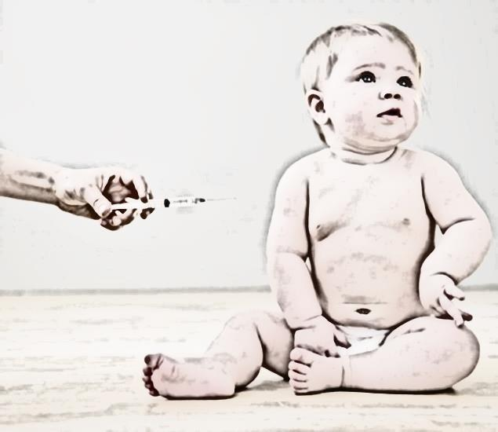
Opinion Editorial Piece

Children’s vaccines as we are all aware have been around for ages and have helped eradicate major illnesses that have once caused death to thousands of infants yearly. Taking a closer look at what vaccines can do for us and our health as a nation, have you ever wondered about the risks of vaccines and what components go into creating the final product that we inject into our own body?
The way I see it, there are many health benefits when you look at the process of vaccinating our children, yet is it the right thing to do by ignoring our body’s own immune system and natural way of fighting off infection and disease? I understand that the risks of not being vaccinated far outweigh the small risks associated with vaccination, but what about the vaccinations that can potentially cause rare yet serious reactions in children including anaphylactic shock, paralysis, and sudden death? Is this risk worth taking, when considering some diseases we vaccinate against are not essentially life threatening, like the chicken pox?
As I try to relate better with one side of the argument, I cannot help but see the potential with both, leaving me in a neutral position. I have personal family experience with not having children vaccinated with leaning towards the natural way but as a nurse working in a pediatric clinic who routinely vaccinates children on a daily basis, I see the good and bad with both sides and ultimately think it should be left up to the individual.

